**CODE ALPHA INTERNSHIP REPORT**

**Muhammad Fahad Ali**

**Task-2 :**

**LOGIN AND REGISTRATION SYSTEM:**

**CODE:**

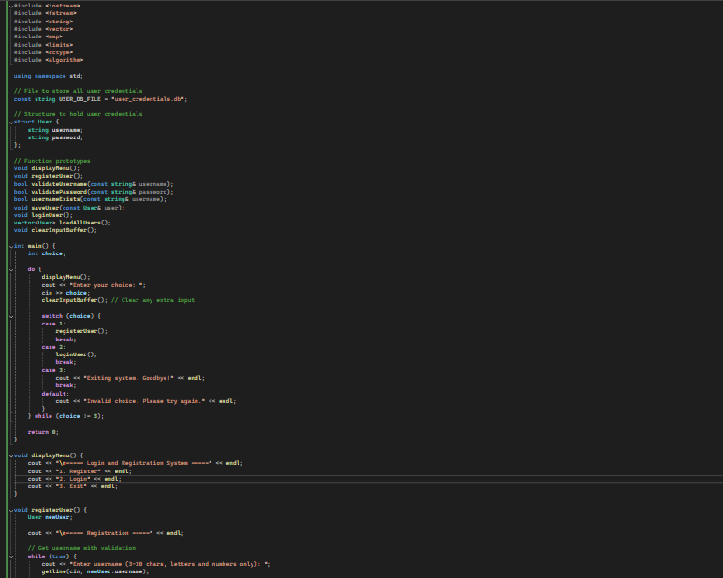

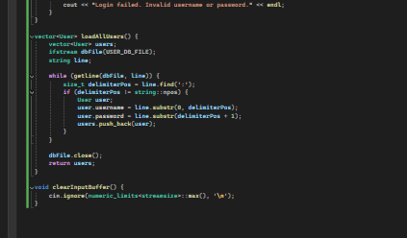

**OUTPUT:**

